**Parent's Consent Form**

ACA-CES-15F: USC-CES J - Parent's Consent Form (Rev 2 | Effective on November 2022)

Date: January 13, 2023

I, the parent/ guardian of Christian Stewart, do allow my son/daughter to join the Community Extension Services activities specified below that are organized by the USC-CES Office in coordination with his/her department and school. I understand further, that these activities intend to expose my son/daughter to the realities of society that is consistent with the Education with a Mission provided by the university. Finally, that these will help hone him/her as a Witness to the Word.

|  |  |  |  |
| --- | --- | --- | --- |
| **Assigned CES Activity** | **Schedule** | **Venue** | **Specific Date of Deployment** |
| Jpic-IDC, Inc. San Carlos Community-Based Learning Center Digital Hub Inauguration | January 29 (Sun) 8:00am-12:30pm | L. Jaime Street, Maguikay , 6014 Mandaue City , Cebu | January 29, 2023 |

I am conscious of the risks and benefits involved in this activity. Having obtained permission, my child has the

responsibility of safeguarding himself/herself in the entire duration of each activity.

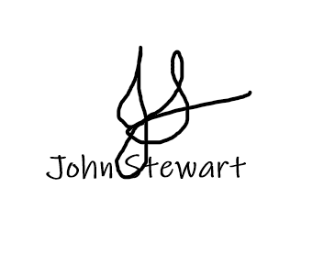

Sincerely yours, 

_____________January 13, 2023______________

Name and Signature of Parent/Guardian and Date

-----------------------------------------------------------------------------------------------------------------------------------------------------------------------------------

Parent’s Copy



|  |  |  |  |
| --- | --- | --- | --- |
| **Assigned CES Activity** | **Schedule** | **Venue** | **Specific Date of Deployment** |
| Jpic-IDC, Inc. San Carlos Community-Based Learning Center Digital Hub Inauguration | January 29 (Sun) 8:00am-12:30pm | L. Jaime Street, Maguikay , 6014 Mandaue City , Cebu | January 29, 2023 |

I am conscious of the risks and benefits involved in this activity. With this, I have given my child the needed permission to participate and have duly instructed her/him to take responsibility in safeguarding herself/himself for the entire duration of said activity.

_____________January 13, 2023_____________

Name and Signature of Parent/Guardian and Date